Ch. 3-2 The Federal Court System

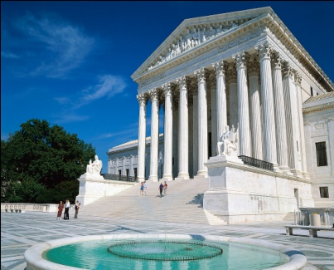Where do federal courts ultimately obtain their powers from?

Did the articles of confederation allow for a supreme court? Why not?

What did the 1891 Judiciary Act establish?

What is general jurisdiction?

What is specialized jurisdiction?

What do federal district courts have original jurisdiction over?

What type of jurisdiction do the federal courts of appeal have?

How many federal courts of appeals are there?

What type of jurisdiction does the United State Supreme Court have?

What is writ of certiorari?

Who can overturn the decision of the Supreme Court?