Photoshop Activity

Twin Em’

* Photograph at least two images of yourself or a classmate, and put them all together in Photoshop to make it look as if you (or they) are relating to themselves in some way. Use one of the photos as the base image, and move the other subjects in the base image to create a unique photo for this assignment.
* 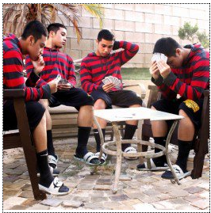Be creative and appropriate

|  |
| --- |
| Proper use of tools and layers |
| Background and other add-ins |
| Neatness |
| Creativity |

