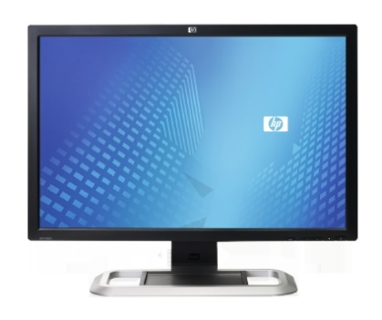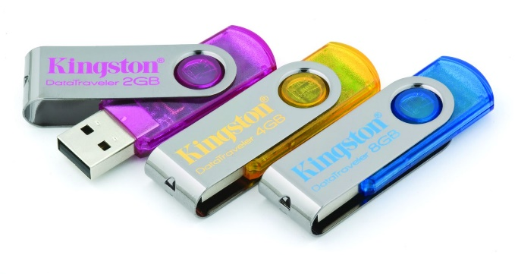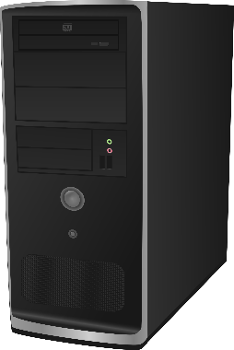 

Hardware & Software

Interactive Notebook

Hardware & Software Terminology

Use this document to organize your notes about hardware & software.

What is the Central Processing Unit?

VS.

**Software:**

**Hardware:**

Operating System-

Application Software-

Operating System-

Output Device

Input Device

What is the system unit and where does it fit in?

Input/Output Devices

After gaining understanding of the difference between input and output, devices classify the devices located in the word bank below.

Output Devices:

Input Devices:

Peripheral Device, what is that?

**Word Bank:**

Monitor

Speaker

Mouse

Keyboard

Flashdrive

Printer

Microphone

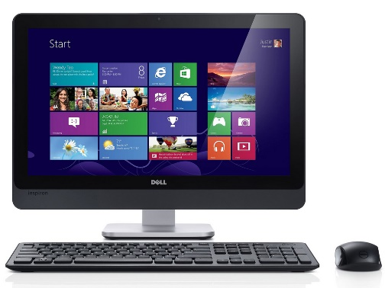

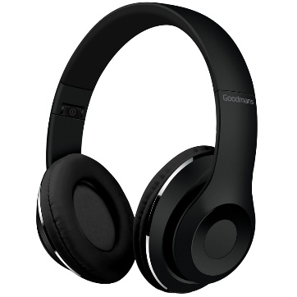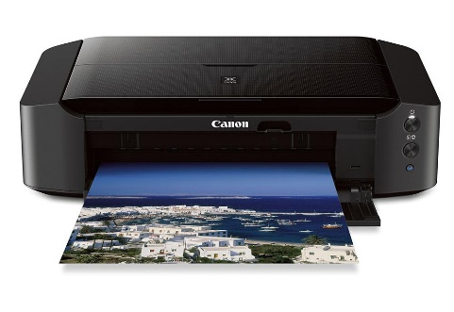

Save Vs Save As

What the difference is between save and save as?

When would you use save? When would you use save as?

What are my options for storing information?

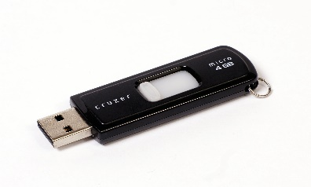

Cloud storage:

Cloud computing:

Storage device:

How Can I Organize My Files?

File Types:

Why is it important for me to understand file types?

File Management:

Write a brief summary pertaining to the information you learned about hardware and software today.