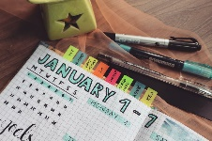
Time Log

Name:
Directions: Record your activities for an entire day. Record how much time you spend on each activity. You will turn this document in to your teacher on _________________. We will analyze & reflect on your daily activities.

*Record activities like: working, completing school work, playing video games, shopping, exercising, on your phone, cleaning, listening/playing music, sleeping, babysitting, getting dressed (shower, hair, makeup) etc.
Daily Activity | Time Started | Time Ended | Adult Signature
- Record the time you woke up
- Record the time you went to bed

