# Consider This Research Project

## Apply your creative thinking and problem solving skills to design and implement a solution.

## Compare Educational/Training Cost

Research information about potential colleges/schools/trainings you may attend. Create a spreadsheet that compares the cost of **four** different colleges/schools/trainings. For each option, find the cost of tuition (for at least 12 hours if it is college), technology/media/or supply fee, and housing fee. Use the concepts and techniques presented in the Excel Part 1 Step by step to format the worksheet. Include a chart to compare the different cost of each college.

* You must include at least four colleges/schools/trainings (Sheet tab name- Cost)
* You must include cost of tuition, technology/media fee supply fee, and housing fee
* Find the total cost to attend the colleges/schools/trainings
* Compare the total cost for each college/schools/trainings by:
  + Find the avg. cost of schooling, the max on your list, and the min
  + Including a chart of the total cost for each school on a separate sheet
    - Be sure to change the sheet tab name to “Chart”
* Format the worksheet
  + Title, merge & center, utilize cell styles, change fonts, font sizes, and font colors, etc.

*Hint most universities have a tuition and fee estimation page. Ex: Google search “University Central Arkansas Tuition”

*Some examples of schools/trainings you might attending other than college include: cosmetology, welding, HVAC, CNA, etc.

Submit your assignment online to the link on ilearn.

Consider how the cost of furthering your education will play a role in your choice in the future.

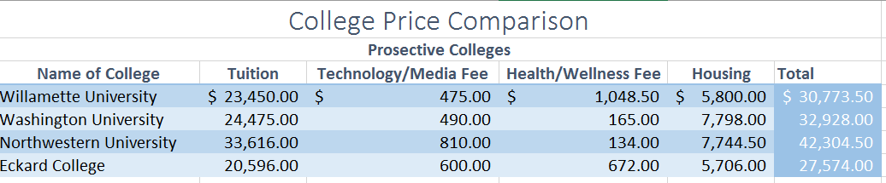Ex:

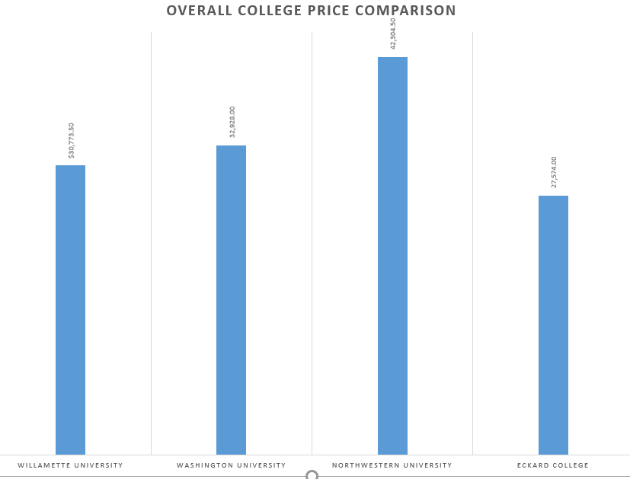

1. Enter a worksheet title and subtitle.
2. Format the worksheet title & subtitle
3. Add a cell style to your row and column headings
4. Add a cell style to your total column or row
5. Add number formatting to your numerical values
6. Adjust any column widths to the widest text entry in each column
7. Organize your information from your research into the worksheet. Include necessary totals.
8. Insert appropriate chart according to your selection. Move the chart to a new sheet, change the chart title, and chart style.
9. Rename and recolor the sheet tabs appropriately.
10. Used AUTOSUM, average, max, and min appropriately.

|  |  |  |
| --- | --- | --- |
| **Task:** | **Point Value :** |  |
| Worksheet title & Subtitle | 4 |  |
| Formatted worksheet title & subtitle | 4 |  |
| Cell style added to column rows and headings | 4 |  |
| Cell style added to total column and row | 4 |  |
| Cell style(s) added to numerical values (cost amounts) | 4 |  |
| Research organized into worksheet along with totals | 16 |  |
| Chart inserted, on new sheet, with chart title and chart style changed. | 24 |  |
| Autosum, AVG, MAX, and MIN used appropriately | 12 |  |
| Renamed sheet tabs | 4 |  |
| Recolor sheet tabs | 4 |  |
| Total Points | 80 test Points |  |