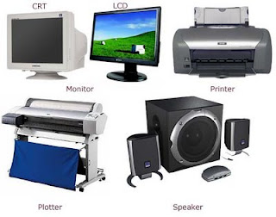

**Instructions:** Using what you have learned in this class, name and describe three input, three output, and three peripheral devices that could be used on a computer. Your description should include how the device is used or its purpose. For example, explain the purpose of keyboard? No devices can be repeated!

|  |  |  |
| --- | --- | --- |
| Input | Output | Peripheral |
|  |  |  |
|  |  |  |
|  |  |  |