Parts of an e-mail

Using the [GCFglobal.org](https://edu.gcfglobal.org/en/email101/common-email-features/1/) website Match the words located in the word bank with the numbered parts of the email (GCFglobal link is also in google classroom). ***On the website, scroll down and click on the orange boxes w/ plus signs to see the name of each part of an email.***

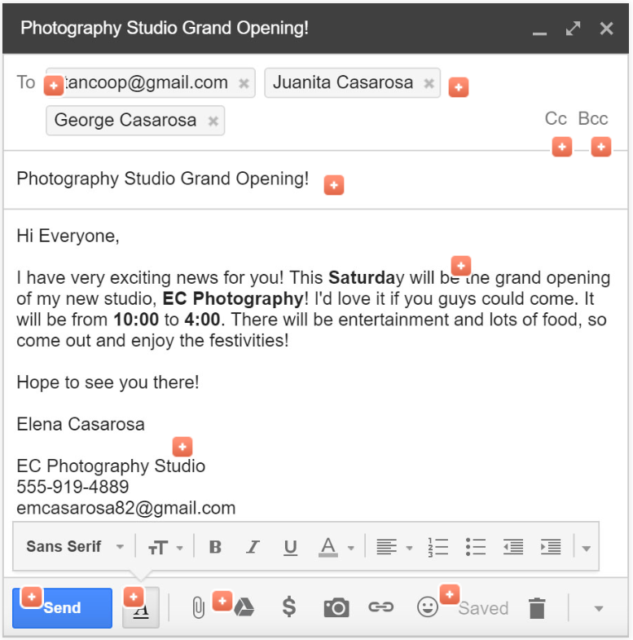







| **Word Bank** | |
| --- | --- |
| Signature | Formatting Options |
| attachments | Subject |
| E-mail Address | Body |





| 1. Example: Subject | 4. |
| --- | --- |
| 2. | 5. |
| 3. | 6. |

Use the [GCFglobal.org](https://edu.gcfglobal.org/en/email101/common-email-features/1/) website to answer the questions below

**Questions:**

1.Why would you use the CC line when sending an email?

2. Why would you use the BCC line when sending email?

3. What is the purpose of a signature in an e-mail?

4. What should you include in an email signature?

5. What are the three main parts of an email?

6. What is smart compose for emails?

7. The image below is an example of an inbox, what is the purpose of an inbox?

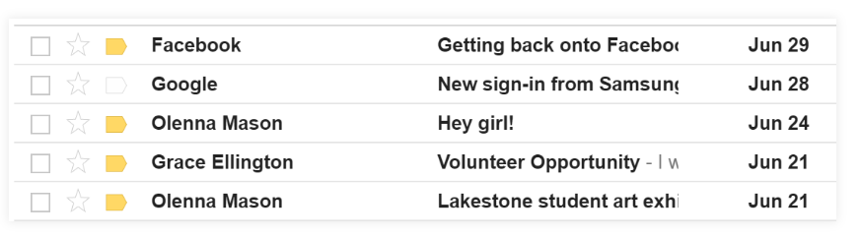

Aspects of g-mail

Using the [GCFglobal.org](https://edu.gcfglobal.org/en/email101/common-email-features/1/) website Match the words located in the word bank with the numbered parts of the gmail aspects (GCFglobal link is also in google classroom)

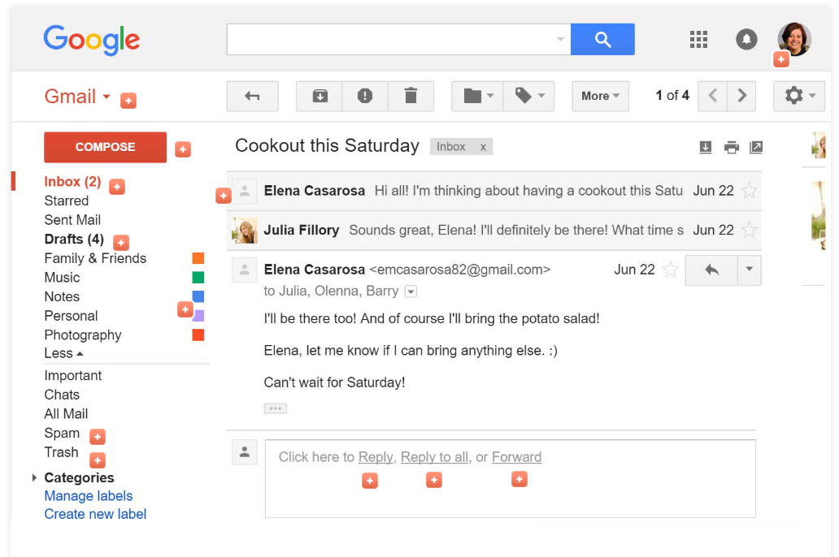







**Word Bank:**

| Inbox | Folders and labels |
| --- | --- |
| Navigation Menu | Sign out |

| 1. | 3. |
| --- | --- |
| 2. | 4. |

**Questions: *On the website, scroll down and click on the orange boxes w/ plus signs to see the name/description of each part of an email.***

Use the [GCFglobal.org](https://edu.gcfglobal.org/en/email101/common-email-features/1/) website to answer the questions below

1. What is the purpose of reply to all? When would you use it?

2. What is the purpose of forward? When would you use it?

3. What does draft mean?

4. What can you access from the navigation menu?

**Scroll down to the Email Etiquette Section (Lesson 4).** Answer the questions below.

1. What is email etiquette?
2. What are some tips for email success?

