Operating System Group Activity

What is an Operating System? Manages all of the software and hardware on the computer. The Operating System coordinates memory, storage, and the central processing unit in order to run the computer’s programs.

Operating systems usually come **pre-loaded** on any computer you buy. Most people use the operating system that comes with their computer, but it's possible to upgrade or even change operating systems.

In your group, you will be assigned one of the following operating systems (share information about the latest version):

* Mac Mojave
* Apple iOS 11
* Linux Mint
* Tizen
* Android 8.0
* Chrome OS
* Windows 10
* Ubuntu

In your group, each person will provide the following information about your assigned operating system. You will collaborate in an Office 365 PowerPoint or Google Slide. You should be able to explain your information in detail. The Manager will be responsible for submitting the file on **iLearn** (you may have to download as a PowerPoint). Make sure you view the downloaded file to make sure you can view everything on your slides. All group member names should be on the file.

* Brief description of the OS
* The type of device this OS is most commonly found on and the cost. (Who would most likely use this OS?)
* Include images of what the OS looks like on devices
* Pros of the OS
* Cons of the OS
* If you had to pick an Operating System to run on your device, which would you choose and why? Why is it important to know information about other operating systems?

Each group will share out about their Operating system. Remember Teamwork!

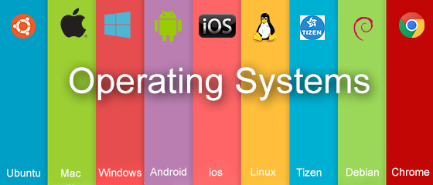

What I Learned About Operating Systems

As your classmates share their presentation about operating systems, you will take notes.

Name:

|  |  |  |
| --- | --- | --- |
| Name of Operating System and **brief**  description | Pros of using this OS  (ventaja) | Cons of using this OS  (desventaja) |
|  |  |  |
|  |  |  |
|  |  |  |
|  |  |  |
|  |  |  |
|  |  |  |
|  |  |  |