All About That Vector!! No Trouble….

Vectors are easy to resize and rescale

Examples of Vectors:

| Original Works Created In Adobe Illustrator | .AI- vector image format created in Adobe Illustrator |
| --- | --- |
| Windows Metafile | .WMF- Microsoft clip art |

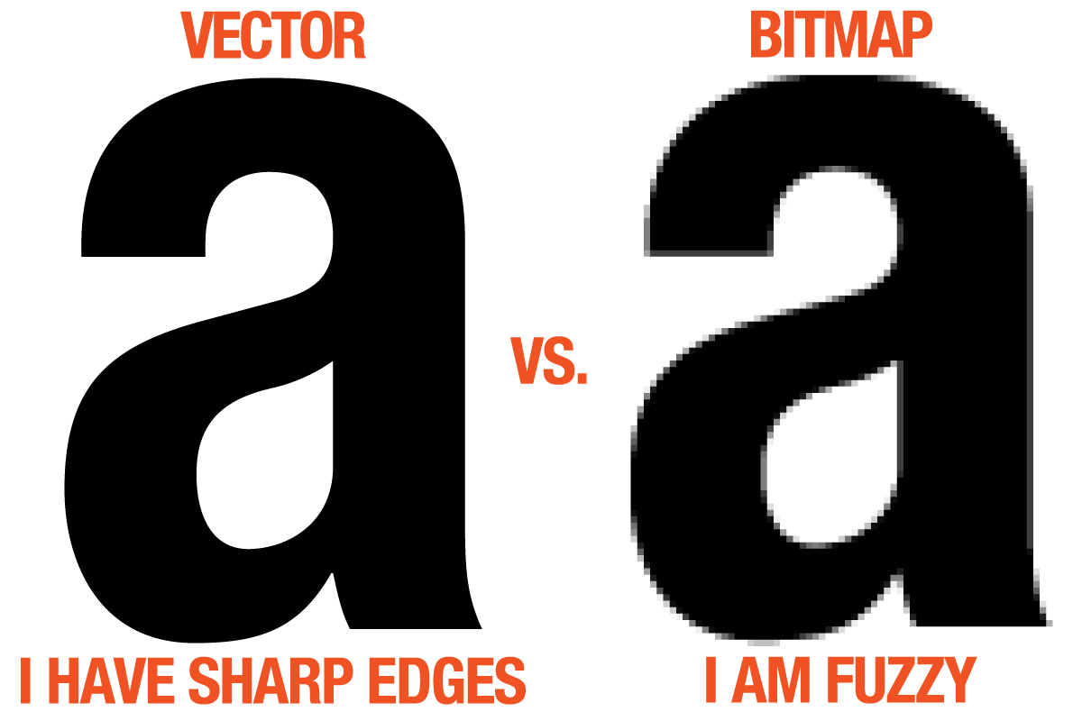

Bit What? BitMap!

| File Format | Definition | Best Used For |
| --- | --- | --- |
| Joint Photographer Experts Group (.jpg) |  |  |
| Bitmap (.bmp) |  |  |
| Portable Network Graphics (.png) |  |  |
| Photoshop Document (.psd) |  |  |
| Tagged Image File (.tif) |  |  |
| Graphics Interchange Format (.gif) |  |  |