Superhero Database

Define, create, and modify a database.

1. Open Access. Click Blank Database. Name the Database **Superhero**
   1. Browse and save the file to your database folder
2. We are going to utilize the information we collected as a class in order to create a superhero database
3. The first step in creating a database is entering in your information (whether it be about customers, clients, products, employees, etc.)
   1. In Access you will enter your information into a table
   2. When you create a blank database it will automatically open a table for you to enter your information.
   3. (Discuss the navigation pane, where objects are located, and how each individual object needs to be saved, as well as the database itself. (I describe it as if the database is the luggage and the objects are the clothes inside))
   4. (Discuss the view that we are working in. There are two views in Access. One is the datasheet view (what do you think it’s used for?) used to enter in the data, and design view is used to edit the design or set up of the object. Show how to switch between views)
   5. We are currently working in datasheet view. Let’s begin creating our table so that we can enter our information.
      1. We are going to enter in our field names on the table. And then we will utilize fields to type in our information about each record, or superhero.
      2. Double click on the Field Name **ID** and change the field name to Superhero.
         1. Change the datatype to short text because we are typing in a short name. (View other datatypes)
      3. Click on the **Click To Add** option in the next row. Our next field name is **Special Power**, what do you think the datatype will be? **Short text**
      4. Walk the students through adding in the rest of the fields and datatypes:
         1. Weakness, Location, Friend, Gender, Arch nemesis, and Super Gadget.
      5. Our table is now set up in Datasheet view in order to enter information.
      6. Sometimes we need to set certain limits, change data types, add captions, specific directions, etc. to our data. In order to edit our settings easier we should switch to design view. When switching between views you’ll be asked to save your objects. Save the table as **Superhero**
         1. In Design view make the following changes and explain field size
            1. Superhero Name: field size 15
            2. Special Power: field size 20
            3. Weakness: field size 15
            4. Location (where the superhero resides) : field size 20
            5. Friend: field size 15
            6. Gender: field size 1
            7. Arch nemesis Name: field size 20
            8. Super Gadget: field size 25
         2. Save the Superhero table (once again state the importance of saving individual objects)
4. Let’s switch back to datasheet view so that we can enter our information about the heroes.
   1. Use the information about 5 superheroes the students gathered in order to fill in the table.
   2. Discuss using tab or clicking to move to the next field.
   3. Save the table

1. Now that we’ve created the superhero table let’s create the villain table. (Be sure to discuss the relationship between the tables –superhero name appears in both tables).
   1. Anytime that you want to create a new object in Access you will utilize the create tab. We are going to create a new table for the villains.
   2. Click the **Create**  tab
   3. Walk the students through adding the following field names to the arch nemesis table. All of them have the data type short text. Have the student go to design view to make changes to the field size.
      1. Arch nemesis name: field size 20
      2. Strength: field size 15
      3. Weakness: field size 15
      4. Gender: field size 1
      5. Evil Plot: field size 30
      6. Superhero Name: field size 15 **\*add description – opponent**
      7. Enter the information the students gathered according to the superheroes that were selected
      8. Save the Super Villain table
2. Sometimes information is given to us in a spreadsheet from an Excel file. In that case we can import our data to a table in Access.
   1. Send students files through lanschool or have them download it off of ilearn
   2. Show students what the spreadsheet looks like and why we wouldn’t just keep it in a spreadsheet.
   3. What does the word **External** mean? Yes, it means outside of. So in order to important information outside of Access we are going to click the **External Data Tab**
   4. We want to import a file, so we will go to the import file group
      1. Make sure you are in the import group!
      2. Where does the file come from? **Excel**  so click the **Excel Button**
      3. Browse for the **Superhero Database Product Table** 
         1. Discuss importing options
         2. Click **OK**
      4. On the next screen make sure the **First Row Contains Column Headings** box is checked. Why do you think we should check that box? This will allow the first row in our spreadsheet to automatically become field names.
      5. Click Next
      6. You can change the field names and data types here if necessary (make no changes) Click **Next**
      7. Choose your own primary key, what do you think the primary key will be? Yes, Super Item. No two items will have the same name. Click **Next**
      8. Name the Table **Product Table** and click **Finish**
      9. Do not save the import step
      10. Open the table and view the import results
3. We’ve entered our information now what? How can we “use” this information
   1. One way to utilize this information is by creating queries. What is a query? A query allows us to ask Access and specific question and returns results to us.

Walk the students through creating the following queries using query design. (Also discuss removing and adding tables in query design)

* 1. Go to the create tab and click on **Query Design,** what view are you in? Design view—it’s the view you use to build queries using field names.
  2. Create a query for the Superhero table that includes the Superhero Name, Special Power, and Weakness field. Save the query as SP1
  3. Create a query for the Superhero table that list all the locations in ascending order. (Sort) Save the query as SP2
  4. Create a query for the Superhero table that includes the Superhero Name, Gender, and Arch nemesis fields for all Superheroes whose names begin with S. (Wildcard S*) Save the query as SP3.

1. Discuss what a report is and that you can create objects from objects other than tables. Create a report from the SP1 query. Save the report as Superhero Report.
2. Discuss what a form is. Create a form from the Super Hero Table. Save the form as Superhero Form.
3. 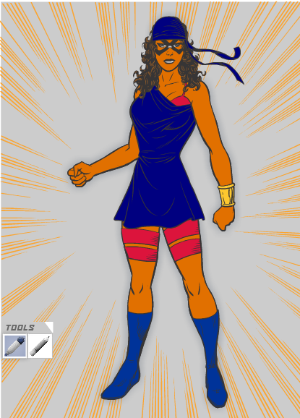 Submit your database to ilearn
4. Superhero database wrap up